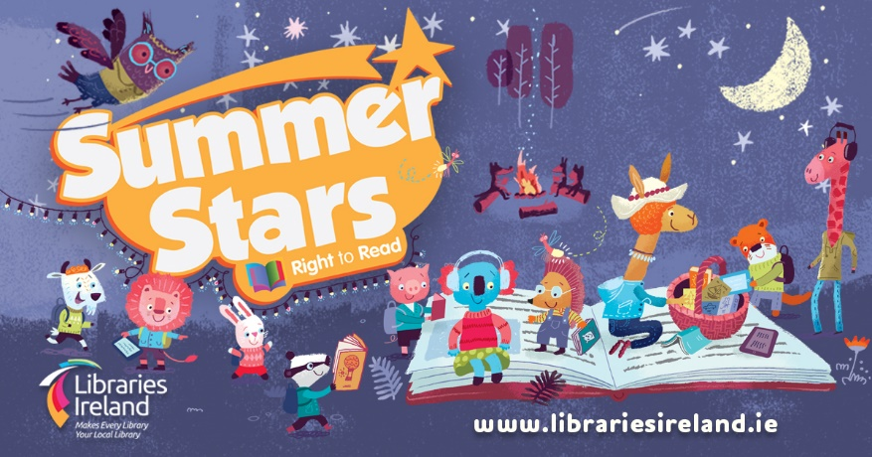
Summer Stars Reading Adventure 2022

Our annual Summer Reading Adventure begins from Friday 1st July for children.
What you need to get started:
- A current library membership: Parents/guardians can sign up new members by visiting your local library or online at kilkennylibrary.ie .
- Summer Stars Reading Card: Collect your card from your local library/download from kilkennylibrary.ie
How does it work?
- The challenge is to read/listen to 8 books over the Summer.
- Borrow books from our libraries or download eBooks / eAudiobooks / eMagazines from our online collection.
- Record your progress on the reading card and bring it into the library to have it signed / stamped by staff.
- Regular prizes will be given out and there will be prize draws in each library for readers that are borrowing books from the library each week.
- Watch out for regular story times and crafts in libraries, and online art workshops, quizzes and recommendations on our website (under What's on) and our social media channels.
- The challenge finishes on Friday 26th August.
Returning your completed card
- When you have finished 8 books, fill in your name and library card number
- Return your card by
  - Handing it in to one of our libraries
  - Emailing a clear scan / image of both sides to outreach@kilkennylibrary.ie
- All completed cards returned by 5pm Friday 2nd September will be entered into our overall prize draw.
- See www.kilkennylibrary.ie or our social media for more information.

